Internal Transfer of Controlled Substances*/* Dangerous Drugs- Request Form

Emory University [Policy 7.25,](https://emory.ellucid.com/documents/view/17543?security=86862ebe35c091de18d4cde8ecf81a73aa785505) does not generally permit the transfer of Controlled Substances and Dangerous Drugs from one Researcher to another. The policy does, however, allow Research Compliance and Regulatory Affairs (RCRA) to review and approve policy exception requests on a case-by-case basis provided there are substantial reasons for the request. Please read below the following before continuing with this form:

* Both researchers must have active GBP/DEA licenses.
* The Supplier must complete a DEA and/or GBP License Verification of the Purchaser’s license(s). See Appendix A & B
* The Researcher to whom the controlled substance is to be distributed must be registered to dispense that controlled substance, which is reviewed during the verification process (CS Only).
* Researchers who maintain a Practitioner license may not transfer controlled substances.
* Controlled substances Schedule I cannot be transferred.

To submit a request, the Emory Researcher should complete this Internal Transfer of Controlled Substances/Dangerous Drugs Request Form and send it to RCRA’s Office of Research Integrity and Compliance (ORIC) at [oric@emory.edu](mailto:oric@emory.edu). Requests will be reviewed on a case-by-case basis. The approval will not set precedence for an investigator or future research.

## Definitions:

# **Supplier**: The Registrant who is transferring the controlled substance/dangerous drug to the purchaser.

# **Purchaser**: The Registrant receiving the transfer of controlled substance/dangerous drug from the supplier.

## Request for Internal Transfer

1. Supplier Name: Click or tap here to enter text.
2. Supplier Contact Information: Click or tap here to enter text.
3. Address where drugs will be transferred from: Click or tap here to enter text.
4. Purchaser Name: Click or tap here to enter text.
5. Purchaser Contact Information: Click or tap here to enter text.
6. Address where drugs will be transferred to: Click or tap here to enter text.

**License Information**

1. Supplier DEA and/or GBP License number (also **attach a copy of licenses**):Click or tap here to enter text.
2. Purchaser DEA and/or GBP License number (also **attach a copy of licenses**):Click or tap here to enter text.

**Purchaser License Verification by Supplier:**

All Suppliers must verify the license of the purchaser online before a transfer request can be approved. Appendix (A) contains the steps to verify the license of a DEA Registrant for the transfer of controlled substances. Appendix (B) contains the steps to verify the license of a Georgia Board of Pharmacy Registrant for the transfer of dangerous drugs. If you are only transferring dangerous drugs, skip steps 9 to12 and 16.

1. Verification of DEA License (if applicable): **attach screenshot of active DEA License of Purchaser.**
2. Purchaser’s DEA License Status: Active  Not Active  Pending  N/A (skip to #13)
3. Purchaser’s DEA License Expiration Date (if applicable): Click or tap here to enter text.
4. Purchaser’s approved drug schedules (if applicable):

|  |  |  |  |  |  |  |  |
| --- | --- | --- | --- | --- | --- | --- | --- |
| II | IIN | III | IIIN | IV | IVN | V | VN |
|  |  |  |  |  |  |  |  |

1. Verification of GBP License: **attach screenshot of active GBP License of Purchaser**
2. Purchaser’s GBP License Status:  Active  Not Active  Pending
3. Purchaser’s GBP License Expiration Date: Click or tap here to enter text.

## Drug Information

1. Controlled Substances requested to be transferred (if applicable):

|  |  |  |  |
| --- | --- | --- | --- |
| **Drug Name** | **Schedule** | **Strength/Concentration** | **Volume/Quantity** |
|  |  |  |  |
|  |  |  |  |
|  |  |  |  |
|  |  |  |  |
|  |  |  |  |
|  |  |  |  |
|  |  |  |  |
|  |  |  |  |
|  |  |  |  |
|  |  |  |  |

NOTE: If applicable, transferring CII CS requires a DEA Form 222. If the Internal Transfer Request Form is approved, a DEA Form 222 must be submitted for review prior to transferring any CS.

1. Dangerous Drugs requested to be transferred:

|  |  |  |
| --- | --- | --- |
| **Drug Name** | **Strength/Concentration** | **Volume/Quantity** |
|  |  |  |
|  |  |  |
|  |  |  |
|  |  |  |
|  |  |  |
|  |  |  |
|  |  |  |
|  |  |  |
|  |  |  |
|  |  |  |

## Justification

1. Fully explain the reason/justification for policy exception request: Click or tap here to enter text.
2. Method of Transfer of Drugs (e.g. hand deliver, ship): Click or tap here to enter text.

## Signatures

1. Purchaser Name and Signature: _____________________ ________________________

Print Name Signature

1. Signature Date: ____________________
2. Supplier Name and Signature: _____________________ ________________________

Print Name Signature

1. Signature Date: ________________________

## Approval Process

# Send the completed Internal Transfer Request Form to [ORIC@emory.edu](mailto:ORIC@emory.edu) for review. Please include copies of applicable license(s) and verification.

# DO NOT transfer CS or DD until the request has been approved, at which time an ORIC representative will send you the appropriate form to transfer CS or DD. If a Schedule II is being transferred, the DEA FORM 222 must be submitted for review prior to transferring CS.

# Appendix A:

## Verification of a Purchaser’s DEA license:

1. The Supplier must complete a DEA Validation prior to requesting and shipping/transferring any controlled substances to a Purchaser. The DEA Validation tool can be found here [DEA Registrant Validation Tool](https://apps.deadiversion.usdoj.gov/webforms2/spring/validationLogin?execution=e4s1) The Supplier will enter their DEA information exactly as it appears on their DEA License. Researchers will use their Last Name and Social Security Number. The Last Name, SSN, Zip Code, and Expiration Date are required. If you cannot proceed you must contact ORIC at [ORIC@Emory.edu](mailto:ORIC@Emory.edu) for assistance.

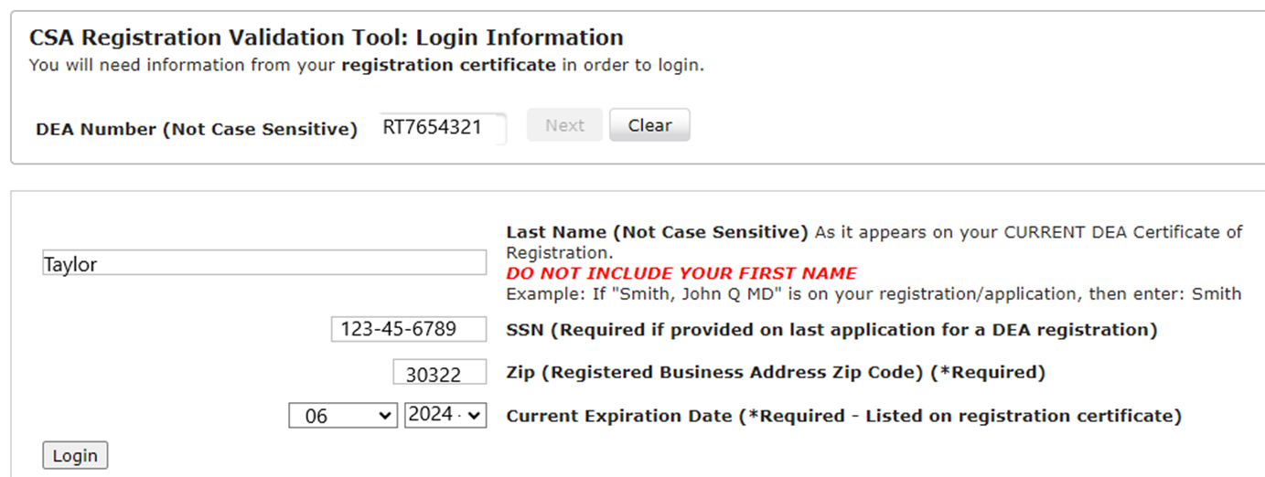

|  |  |
| --- | --- |
|  |  |
|  |  |

1. Read the Data-Use Agreement and check the box at the bottom of the page and then click next.

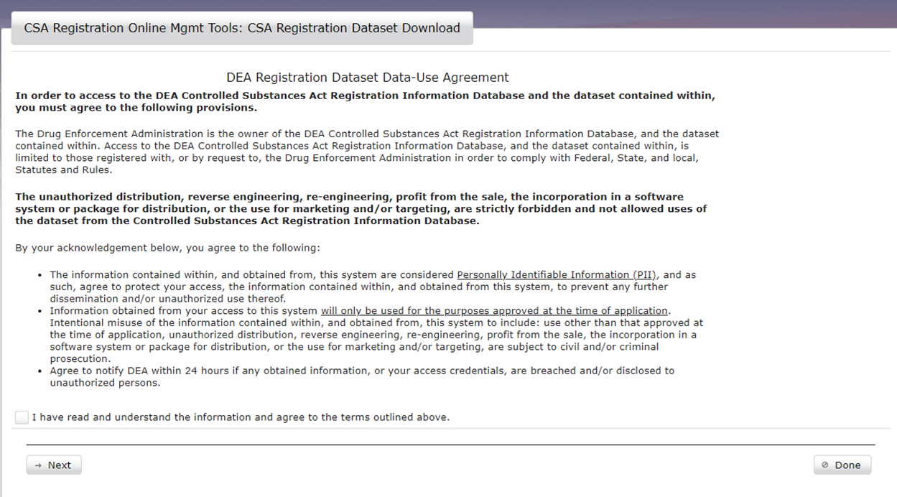

1. Next enter the Purchasers DEA Registration Number and hit validate.

1. The Purchaser’s DEA information will populate.
2. Verify that the Purchaser is authorized to receive the scheduled drug(s) ordered from the Supplier and the Purchaser has an active DEA license.
3. The Registrant Information must be downloaded and saved with the Supplier’s records in the DEA Ready Binder.
4. Click Download Registration Validation. Save and print for filing in the Supplier’s DEA Ready Binder.
5. Scan and send the DEA Registrant validation to [ORIC@emory.edu](mailto:ORIC@emory.edu) with the Internal Transfer Request Form.
6. You will need the information from this validation process for Box 6, of transfer form if approved. You must record the date and the name of the person who conducted the DEA Validation.

# Appendix B:

## Verification of a Purchaser’s GBP license:

1. The Supplier must complete a GBP License Verification prior to transferring any dangerous drugs to a Purchaser. It is not enough to visually see a license. The Supplier must use the tool provided to verify the Purchaser’s license is **active** online.
2. The GBP Verification tool can be found here [GBP Facility License Verification](https://gadch.mylicense.com/verification/Search.aspx?facility=Y). The Supplier will enter the Purchaser’s GBP license number information exactly as it appears on the GBP License and then click next.

1. A screenshot of a computer

   Description automatically generatedThe Purchaser’s GBP License information will appear in the window. Click on the Name.
2. The Purchaser’s name, address, license number, expiration date, and license status must be verified.

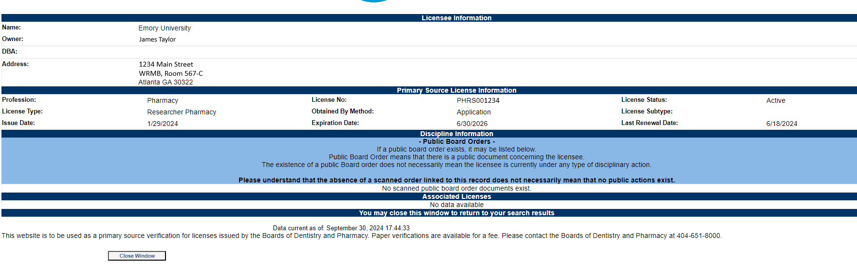

1. Take a screenshot of this page and send with the Internal Transfer Request Form.
2. Print a copy of the page and keep it in the Supplier’s GDNA/DEA Ready Binder along with the Internal Transfer of Controlled Substances/ Dangerous Drugs Request Form and DEA Form 222 (if applicable).
3. If transfer is approved, complete Form J and/or Form 14 to document the drug transfer. Maintain a copy/copies in Supplier’s and Purchaser’s Ready Binder.

# Internal Transfer Request Approval Form:

**RCRA: Internal Use Only**

**Request received on: ___________________(date)**

Name of ORIC Representative who review this form:

**Transfer Plan and documentation review by ORIC:**

Appropriate License(s) is/are active

License Verification(s) was/were completed

Purchaser’s DEA License is approved to obtain the requested drug schedule

**Request decision**

Granted: If granted, ORIC will send the appropriate form to document the transfer.

Not granted:

Signature of AVP:

Date:

ORIC Representative reviewed Transfer Documents after approval (including DEA Form 222, if applicable)