Working Instructions Form 8: Schedule I – II Controlled Substance Receiving Log

Definitions:
- controlled substance - The Controlled Substances Act (CSA) places all substances that were in some manner regulated under existing federal law into one of five schedules. This placement is based on the substance’s medical use, potential for abuse, and safety or dependence liability. More information can be found in Title 21 United States Code (USC) Controlled Substances Act Alphabetical List of Controlled Substances
- Registrant – A person licensed and registered with DEA to distribute, manufacture, administer, dispense, import, or export a controlled substance.

Box 1 Instructions: Registration Information
- Complete the Registrant’s Name, DEA #, and address in this section. The information must appear exactly (in its entirety), as it does on the Registrant’s DEA License.

Box 2 Instructions: Receiving Log for all Schedule I – II Controlled Substances
- Record each Schedule I – II controlled substance received on a separate line by concentration/strength. This form does not replace the DEA Form 222. All orders must first be received on the official DEA Form 222.
- For each controlled substance received, you must document the DEA Form 222 for the ordered drug. You may find the DEA Form 222 Order Form number in the Registrant Information section on the DEA Form 222 used to order the controlled substance.

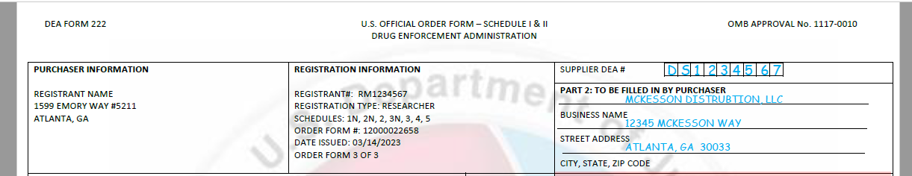

3. Record the name of the controlled substance, the concentration/strength, volume/quantity of each container, and the drug form, exactly as it appears on
the container received.
4. Record the total number of containers received.
5. Document the PO # from which the order was placed.
6. Record the date the drug was received at the registered location and the person receiving the drug in the inventory.

Sample Form 8: Schedule I – II Controlled Substance Receiving Log

Note: All Schedule I-II Controlled Substances must be received on the DEA Form 222. This form is not a substitute for receiving the controlled substance on the official form.

Box 1: Registrant Information
Registrant’s Name: Joe Smith | DEA #: RS1234567 | Registered Address: 123 Main Street, Room 123, Atlanta, GA, 30325

Box 2: Receiving Log for all Schedule I – II Controlled Substances
DEA Form 222 Order Form # | Name of the Controlled Substance | Concentration/Strength | Volume/Quantity of each container | Drug Form | Number of Containers | PO # | Date Received | Name of Person Receiving the C/S
1245889560 | Psilocybin | 100 | 5 grams | powder | 1 | PO1263749 | 07/01/23 | Joe Smith
1245889560 | Oxycodone HCL | 100 | 10 grams | powder | 1 | PO1263749 | 07/01/23 | Joe Smith
4385489540 | Dexmethylphenidate HCL | 5mg | 100 | tablets | 4 | PO8458489 | 07/15/23 | Joe Smith
2732898349 | Morphine Sulfate ER | 20mg | 1000 | capsule | 1 | PO8548984 | 07/25/23 | Joe Smith
2732898349 | Fentanyl Base | 100 | 1 gram | powder | 1 | PO8548984 | 07/25/23 | Joe Smith
 |  |  | SAMPLE

Form 8: Schedule I – II Controlled Substance Receiving Log

Note: All Schedule I-II Controlled Substances must be received on the DEA Form 222. This form is not a substitute for receiving the controlled substance on the official form.

Box 1: Registrant Information
Registrant’s Name: | DEA #: | Registered Address:

Box 2: Receiving Log for all Schedule I – II Controlled Substances
DEA Form 222 Order Form # | Name of the Controlled Substance | Concentration/Strength | Volume/Quantity of each container | Drug Form | Number of Containers | PO # | Date Received | Name of Person Receiving the C/S

