Working Instructions: Form 14 – Controlled Substance Internal Transfer Form

Definitions:
- Controlled Substance - The Controlled Substances Act (CSA) places all substances which were in some manner regulated under existing federal law into one of five schedules. This placement is based on the substance’s medical use, potential for abuse, and safety or dependence liability. More information can be found in Title 21 United States Code (USC) Controlled Substances Act Alphabetical List of Controlled Substances
- Registrant – A person licensed and registered with DEA to distribute, manufacture, administer, dispense, import, or export a Controlled Substance.
- Supplier – A DEA Registrant who sells or transfers a controlled substance to another DEA Registrant
- Purchaser – A DEA Registrant who purchases and receives controlled substances from a DEA Registered and approved Supplier.

Process Working Instructions:

- Before starting this process, consult the Office of Research Integrity and Compliance. Email this completed form to oric@emory.edu for review.

- The Purchaser shall fill out Box 1, 2, and 3, make a copy of Form 14, and then maintain the copy in the Purchaser’s DEA records. If the Controlled Substance is Schedule I-II then the Purchaser shall fill out DEA Form 222 according to § 1305.12 Procedure for executing DEA Forms 222, make a copy for the Purchaser’s records. Then the Purchaser will send the original Form 14 and the original DEA Form 222 to the Supplier. *Reminder – Retain copies of Form 14 and DEA Form 222(if applicable).

- The Supplier receives Form 14/DEA Form 222 and conducts a DEA Validation of the Purchaser’s DEA License (DEA Validation Tool). The Supplier will complete Box 4 and 6 on Form 14. If the Supplier also received a DEA Form 222 for a Schedule I-II order, then the Supplier will complete DEA Form 222 according to § 1305.13 Procedure for filling DEA Forms 222. The Supplier will then ship the controlled substances to the Purchaser through a common or contract carrier as required by § 1301.74. The Supplier retains the original Form 14 and the DEA Form 222 (if applicable) for their DEA records.

- The Purchaser receives the controlled substances and completes Form 14 and DEA Form 222(if applicable) by filling out Box 5 and 7 on the Purchaser’s copy. The purchaser maintains the completed Form 14 and DEA Form 222(if applicable) in their DEA records.

Form Working Instruction:

Box 1: Supplier Registration Information
- This box is to be completed by the Purchaser. Record the Supplier’s Registrant Name, DEA #, and address in this section. The information must appear exactly (in its entirety), as it does on the Supplier’s DEA License.

Box 2: Purchaser Registration Information
- This box is to be completed by the Purchaser. Record the Purchaser’s Registrant Name, DEA #, and address in this section. The information must appear exactly (in its entirety), as it does on the Purchaser’s DEA License.

Box 3: Controlled Substances Drug and Transfer Information
- Box 3 is to be filled out by the Purchaser. Enter the Name of the Substance, Concentration/Strength, Container Size, Drug Form (liquid, powder, tablet, capsule), Number of containers requested, and the Total Volume/Quantity being purchased.

Box 4: Supplier Shipping Information
- Box 4 is to be completed by the Supplier. The Supplier is to record the number of containers shipped per line and the date the drug shipped.

Box 5: Purchaser Receipt Information
- Box 5 is to be completed by the Purchaser. The Purchaser is to inventory the shipment once it arrives. Record the number of containers received per line and the date the shipment was received by the purchaser. The date received must be the date it is physically received in the lab/office.

Box 6: Supplier Transfer Information
- Box 6 is to be completed by the Supplier. The Supplier must complete a DEA Validation prior to shipping any controlled substances to a Purchaser. The DEA Validation tool can be found here DEA Registrant Validation Tool. The Supplier will enter their DEA information exactly as it appears on their DEA License. Researchers/Practitioners will use their Last Name and Social Security Number. The Last Name, SSN, Zip Code, and Expiration Date is required. If you cannot proceed, you must contact ORIC at ORIC@Emory.edu for assistance.

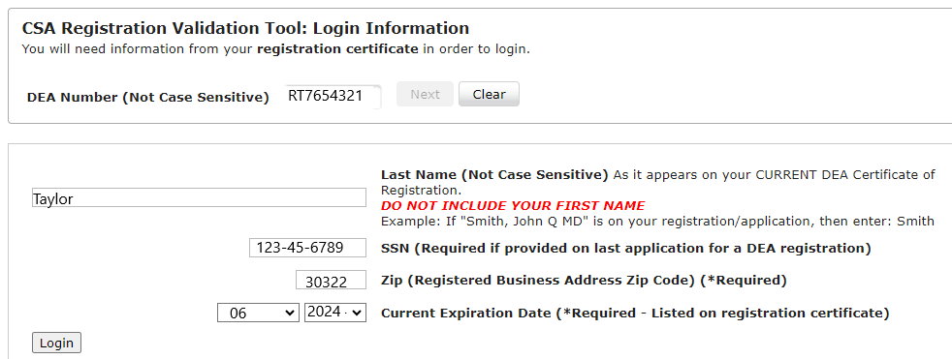

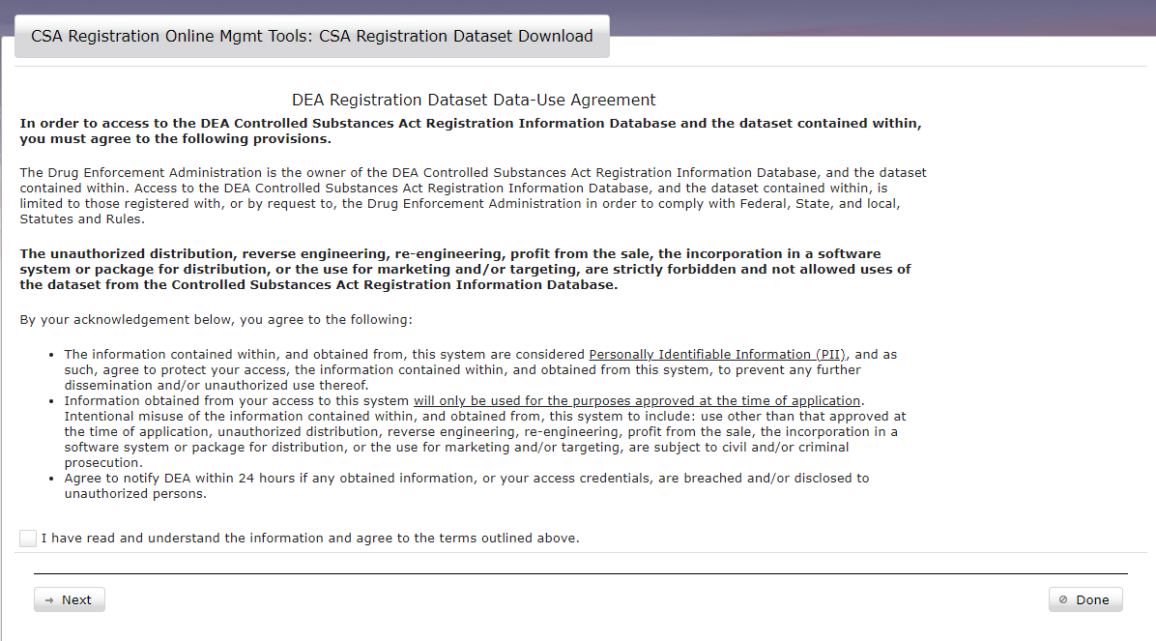
- Read the Data-Use Agreement and check the box at the bottom of the page and then click next.

- Next enter the Purchasers DEA Registration Number and hit validate.
- The Purchasers DEA information will populate.

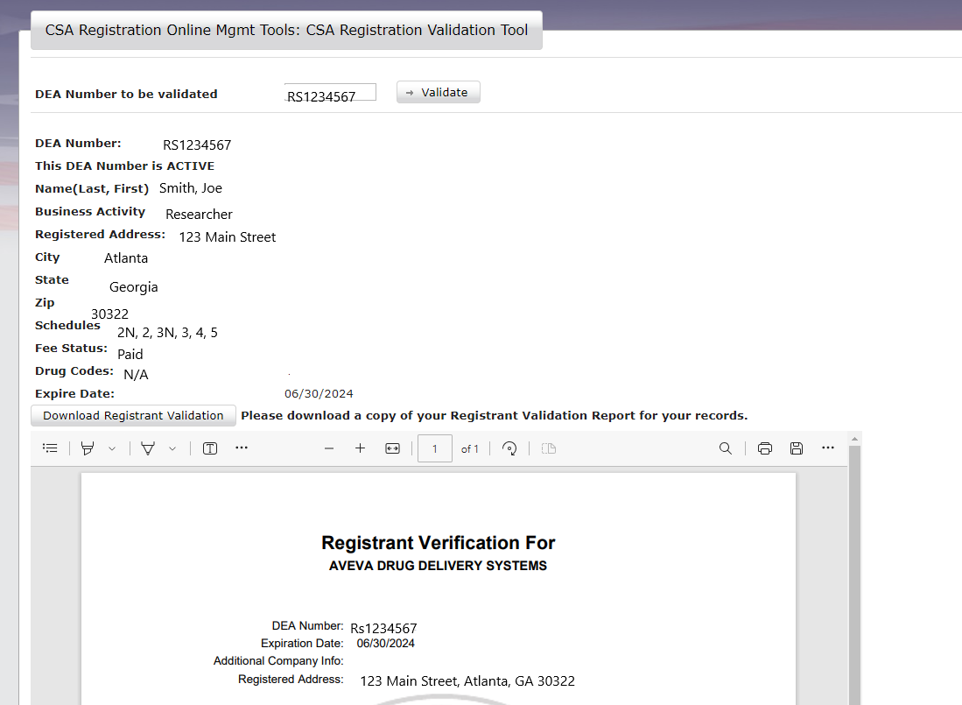

5. The Registrant Information must be downloaded and saved with the Supplier’s records in the DEA Ready Binder.
6. Click Download Registration Validation. Save and print.
7. In Box 6, record the date the Supplier conducted the DEA Validation.
8. Verify on the printout that the Purchaser is authorized to receive the scheduled drug ordered.
9. Record the person who conducted the Validation and shipped the controlled substance.

Box 7: Purchaser Transfer Information
- Once the controlled substances are received, the Purchaser must record the name of the person receiving the controlled substance, sign, and date on the date the drugs were received.
- For Schedule I – II drugs, a DEA Form 222 is required. Record the DEA Order Form Number and the date the DEA Form 222 was issued by DEA.

Sample Form 14-CONTROLLED SUBSTANCE INTERNAL TRANSFER FORM
SCHEDULE I – II CONTROLLED SUBSTANCES ONLY (DEA FORM 222 REQUIRED)

Note: This form is to be used to track the internal transfer of Schedule I -II controlled substances. Schedule I – II drugs require a DEA Form 222. A DEA License verification must be conducted prior to transferring any controlled substances.
Box 1: Supplier Registrant Information
Registrant’s Name: Joe Smith | DEA #: RS1234567 | Registered Address: 123 Main Street, Atlanta, GA, 30325 | Authorized Schedules: 1N, 2N, 2, 3N, 3, 4, 5

Box 2: Purchaser Registrant Information
Registrant’s Name: JoAnn Taylor | DEA #: RT7654321 | Registered Address: 456 Emory Way, Atlanta, GA, 30325 | Authorized Schedules: 2N, 2, 3N, 3, 4, 5
Note: Record the total quantity of the substance to the nearest metric unit weight or the total number of units. The log balance must always match the physical balance of Controlled Substances. Any log discrepancies, or other circumstances that indicate significant loss or theft of controlled substance must be promptly reported using Form 5.
Box 3: Controlled Substances Information |  |  |  |  |  | Box 4: Supplier Shipping Info |  | Box 5: Purchaser Receipt Info
Name of the Substance | Concentration/Strength | Container Size | Drug Form | Number of Containers Requested | Total Volume/Quantity | Supplier Ship Date | Number Shipped | Purchaser Receipt Date | Number Received
Fatal Plus | 390mg/ml | 250ml | liquid | 1 | 250ml | 05/01/23 | 1 | 05/01/23 | 1

Box 6: Supplier Transfer Information
DEA Verification Completion Date (Attach documentation): 04/30/23 | Authorized to receive schedules shipped (Y/N): Yes | Person Authorized to Ship: Joe Smith
Box 7: Purchaser Transfer Information
Receiving Employee Name: JoAnn Taylor | Signature: JoAnn Taylor | Date: 05/01/23
DEA 222 Order Form Number: 12000022658 |  | Date Issued: 03/14/2022

Sample Form 14-CONTROLLED SUBSTANCE INTERNAL TRANSFER FORM
SCHEDULE III – V CONTROLLED SUBSTANCES ONLY

Note: This form is to be used to track the internal transfer of Schedule III - V controlled substances. A DEA License verification must be conducted prior to transferring any controlled substances.
Box 1: Supplier Registrant Information
Registrant’s Name: Joe Smith | DEA #: RS1234567 | Registered Address: 123 Main Street, Atlanta, GA, 30325 | Authorized Schedules: 1N, 2N, 2, 3N, 3, 4, 5

Box 2: Purchaser Registrant Information
Registrant’s Name: JoAnn Taylor | DEA #: RT7654321 | Registered Address: 456 Emory Way, Atlanta, GA, 30325 | Authorized Schedules: 2N, 2, 3N, 3, 4, 5
Note: Record the total quantity of the substance to the nearest metric unit weight or the total number of unit. The log balance must always match the physical balance of Controlled Substances. Any log discrepancies, or other circumstances that indicate significant loss or theft of controlled substance must be promptly reported using Form 5.
Box 3: Controlled Substances Information |  |  |  |  |  | Box 4: Supplier Shipping Info |  | Box 5: Purchaser Receipt Info
Name of the Substance | Concentration/Strength | Container Size | Drug Form | Number of Containers Requested | Total Volume/Quantity | Supplier Ship Date | Number Shipped | Purchaser Receipt Date | Number Received
Ketamine | 100 mg/ml | 10ml | liquid | 1 | 10ml | 05/01/23 | 1 | 05/01/23 | 1
Euthosol | 100 mg/ml | 10ml | liquid | 1 | 10ml | 05/01/23 | 1 | 05/01/23 | 1
Testosterone | 100 | 5g | powder | 1 | 5g | 05/01/23 | 1 | 05/01/23 | 1

Box 6: Supplier Transfer Information
DEA Verification Complete Date (Attach documentation): 04/30/23 | Authorized to receive schedules shipped (Y/N): Yes | Person Authorized to Ship: Joe Smith
Box 7: Purchaser Transfer Information
Receiving Employee Name: JoAnn Taylor | Signature: JoAnn Taylor | Date: 05/01/23

Form 14-CONTROLLED SUBSTANCE INTERNAL TRANSFER FORM
SCHEDULE I – II CONTROLLED SUBSTANCES ONLY (DEA FORM 222 REQUIRED)

Note: This form is to be used to track the internal transfer of Schedule I -II controlled substances. Schedule I – II drugs require a DEA Form 222. A DEA License verification must be conducted prior to transferring any controlled substances.
Box 1: Supplier Registrant Information
Registrant’s Name: | DEA #: | Registered Address: | Authorized Schedules:

Box 2: Purchaser Registrant Information
Registrant’s Name: | DEA #: | Registered Address: | Authorized Schedules:
Note: Record the total quantity of the substance to the nearest metric unit weight or the total number of units. The log balance must always match the physical balance of Controlled Substances. Any log discrepancies, or other circumstances that indicate significant loss or theft of controlled substance must be promptly reported using Form 5.
Box 3: Controlled Substances Information |  |  |  |  |  | Box 4: Supplier Shipping Info |  | Box 5: Purchaser Receipt Info
Name of the Substance | Concentration/Strength | Container Size | Drug Form | Number of Containers  Requested | Total Volume/Quantity | Supplier Ship Date | Number Shipped | Purchaser Receipt Date | Number Received

Box 6: Supplier Transfer Information
DEA Verification Complete Date (Attach documentation): | Authorized to receive schedules shipped (Y/N): | Person Authorized to Ship:
Box 7: Purchaser Transfer Information
Receiving Employee Name: | Signature: | Date:
DEA 222 Order Form Number: |  | Date Issued:

Form 14-CONTROLLED SUBSTANCE INTERNAL TRANSFER FORM
SCHEDULE III – V CONTROLLED SUBSTANCES ONLY

Note: This form is to be used to track the internal transfer of Schedule III - V controlled substances. A DEA License verification must be conducted prior to transferring any controlled substances.
Box 1: Supplier Registrant Information
Registrant’s Name: | DEA #: | Registered Address: | Authorized Schedules:

Box 2: Purchaser Registrant Information
Registrant’s Name: | DEA #: | Registered Address: | Authorized Schedules:
Note: Record the total quantity of the substance to the nearest metric unit weight or the total number of units. The log balance must always match the physical balance of Controlled Substances. Any log discrepancies, or other circumstances that indicate significant loss or theft of controlled substance must be promptly reported using Form 5.
Box 3: Controlled Substances Information |  |  |  |  |  | Box 4: Supplier Shipping Info |  | Box 5: Purchaser Receipt Info
Name of the Substance | Concentration/Strength | Container Size | Drug Form | Number of Containers  Requested | Total Volume/Quantity | Supplier Ship Date | Number Shipped | Purchaser Receipt Date | Number Received

Box 6: Supplier Transfer Information
DEA Verification Complete Date (Attach documentation): | Authorized to receive schedules shipped (Y/N): | Person Authorized to Ship:
Box 7: Purchaser Transfer Information
Receiving Employee Name: | Signature: | Date:

